# MACHINE LEARNING FOR IMAGING

(please don’t assume my answers are correct)

Please feel free to add your solutions as well :)

Question 1a

1. B (higher order value) (2023: should be C from EdStem: <https://edstem.org/us/courses/29423/discussion/2779088>) Actually depend on the # of the parameters
2. D (3*64*64+1)
3. B

1. C

2

Question 1B

(Not sure about 1b (i). So if someone has a more detailed solution that would be great.) (2023: what made the most sense to me from the hint is a line that crosses (5, 0) and (0, -5) since I got the minimum error from it someone mind confirming they got something similar?)

c)

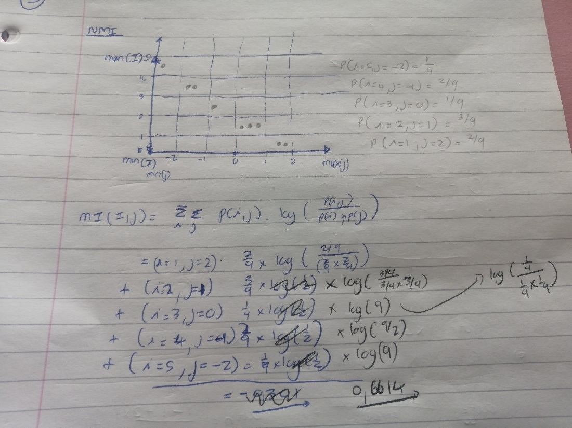

(Not sure about this NMI calculation) (2023 - I got the same thing

You can use the formula: NMI = (H(I)+H(J))/H(I,j) . When you start calculating this you will see that H(I) = H(J) = H(I,j)/2, thus the NMI is equal to 1.

e)

**Question 2**

1. See Week 3 QnA for answers

i) 1st and 3rd

ii) 2nd

iii) 1st, 2nd, 3rd, 5th

iv) sigmoid and tanh

f

iii) Separate object classification and object detection (see week 7 QnA for answers)

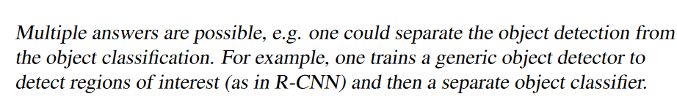

C)(i)

Clarification – L1 loss is MAE, L2 loss is MSE

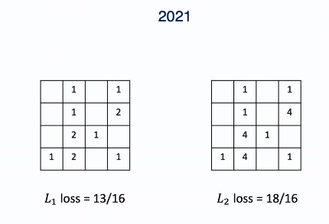

ii) 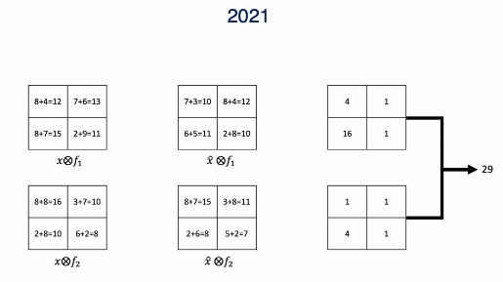

D)

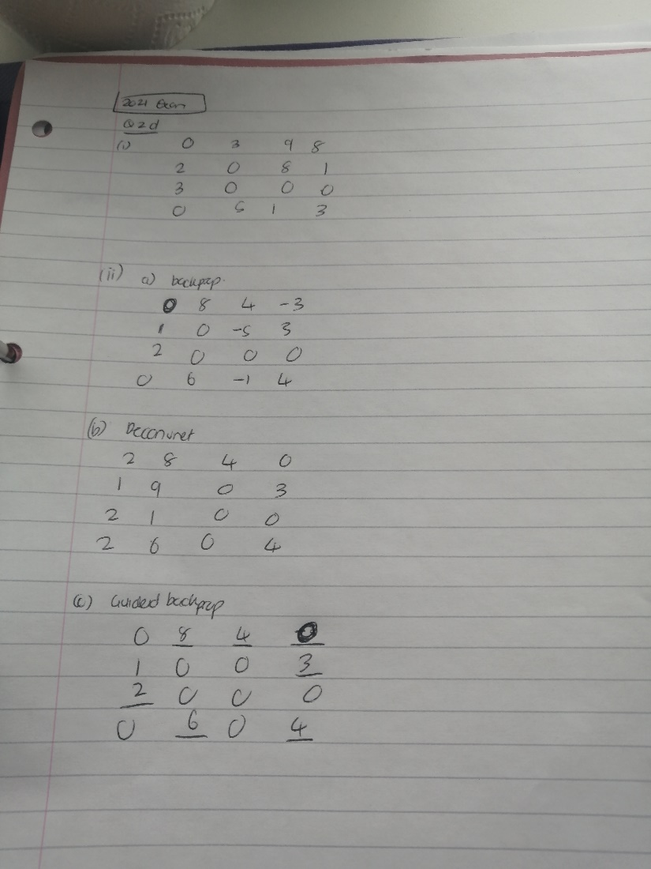

III) 7.99 2.01 3.01 4.01  
 1.01 3.99 5.01 5.99

2.01 4.99 3.01 2.01

1.01 7.01 -0.01 9.01

Noise = eps * sign of ΔL/x

Adversarial eg = x + noise

Answers from week 8 Q&A:

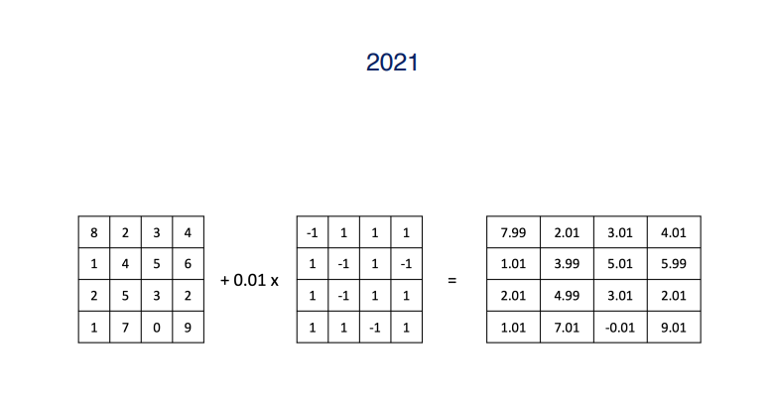

IV) Despite epsilon being small, this adjusts the input pixels in the direction that maximises the loss (direction of the gradient). I.e. opposite of gradient descent method during training where we minimise the loss by moving in a small step in direction of the negative gradient

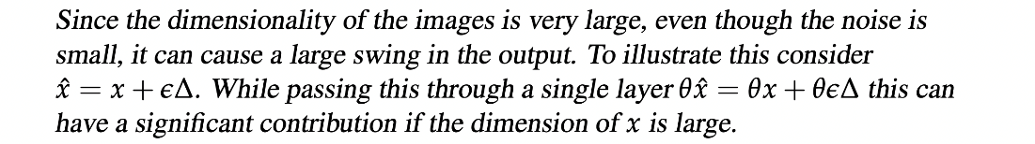 - THIS IS FROM Q-A-WEEK 8